30th September 2026

Internship Project Certificate

This is to certify Ms. Renuka B M (Reg.No:122311510105), B.Tech (Computer Science and Engineering) student of The Apollo University, Chittoor has successfully completed the project titled "AI Supply Chain Disruption Predictor using News NLP Weather Data", from May 2026 to July 2026 in the Machine Learning Domain.
We have found her contributions to the project were valuable, and she demonstrated a high level of dedication, skill, and professionalism throughout her time with us.
We are proud to have Ms. Renuka B M as part of our team and wish her continued success in her future endeavours. We wish her the best for her future.

For Gradtwin Services (OPC) Private Limited
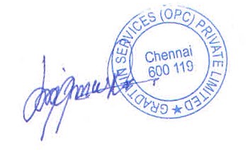

Kanishrajiah Durairaju

Manager - Human Resource

